//EXTERIOR - ICE CAVERN//
Darkness. Ragul was floating in an endless void.
Ragul: Na sethutana yenna? Illa… yenaku vazhikudhu… yennoda nenju… (breathing heavy) pudicha madhiri iruku
Sounds of snow crunching.
He saw flashes of something, people walking like robots with no emotions towards him, bringing various items like fruits, leaves, bark, glowing items.
Ragul: Yenna nadakudhu inga? Yaaru ivungalam? Yennala ivungala yeppadi paaka mudidhu? Idhellam nejama illa kanava?
The dream shifted and the place turned pitch dark except for the glowing item and it started to change colours. The colour of the ball determined the landscape. The ball changed to green and the landscape became a grassland, suddenly it turned red and the area became a volcano. Slowly its size grew bigger and bigger.
Ragul was terrified and it totally emitted a full blown flash blinding the eye.
At that moment, his eyes fluttered open as someone kicked him in the face. The world spun.
Ragul: (to himself) Kanava…
As his vision unblurred he saw the pink-flowered girl stand in front of him.
Ragul: (shocked) Illw, vwnw ywnnw kwllwdhw
His voice was unclear due to the injury in his mouth.
Ragul: (thinking) Yennala move panna mudila… Pesavum mudila. (in pain) ‘Hsss’, yen vai romba eriyudhu. Yennoda vai… odanjirucha yenna?! (realizing) Poachu… Poachu-Poachu-Poachu!
He was tied up near an ice pillar in a sitting position. He slowly looked around.
The pink-flowered girl stood in the snow, breath fogging the air, surrounded by jagged ice and eerie silence. The cavern shimmered faintly, its frozen walls glowing with a soft blue light. Every sound echoed, his screeches, her footsteps, the crunch of snow beneath his butt. At the far end, various shadowed openings hinted at deeper chambers. The cavern shimmered faintly due the luminescent water mildly flowing in front of the snowsurface, its frozen walls reflecting the blue light giving an otherworldly glow.
There were also leftovers from a bonfire.

She stared at his hoodie and black pants.
Pink-flowered girl: (surprised) Yaar-ra nee?! Yepdi-da inga vandha?!
Ragul blinked with confusion as he slowly moved his arm near his mouth. He was terrified and ignored er words.
Ragul instantly tried to remove the knife, but even a slight movement of his mouth sent a jolt of pain. His hands and feet shook in agony.
Ragul: (thinking) Bayangarama valikduhu. (to the Pink-flowered Girl): Idhw Ywdwthw vwdw!
His breathing quickened again. He gave a weak scream, trying to break free of the rope he was tied.
Pink-flowered girl: Ippo nee yenaku badhil sollana, unnaya ingaye konnuduvan. Unakum yenakum mattum dha vali na yenna-nu theriyum inga. Oruthar kooda unna pathi care panna matanga. So, sollu… yaar nee? God Zitabye yenga irukarunu theriyuma unaku?
Her words sounded distant. He blinked, trying to understand, but his mind spun. His breathing became faster, shallow, panicked.
Ragul: (tense, to himself) Yenna sonna iva? Yenaku seriya kekala?!
He tried to move his arm to break free of the ropes his body was tied to, but he couldn’t, it felt heavy. His body wouldn’t respond. His cheek throbbed again, sending another wave of pain through his head.
Ragul: (in mind, screaming) AAAAHHH!! (thinking) Ippo yennala katha kooda mudiyadhu! Yen vai bayangarama yeriyudhu. Yennala pesa vera mudila. Ippo yenna pandradhu? Aaaaaah!!!
Ragul instantly tried to remove the knife by bending his neck forward and reaching his face to his arms, but even a slight movement of his mouth sent a jolt of pain. His hands and feet shook in agony.
Ragul: (thinking) Illa…illa..illa…valikudhu. (to the Pink-flowered Girl): Idhw Ywdwthw vwdw plwwsw
Pink-flowered girl: Kekala. Olunga sollu. Unaku God yenga irukaru-nu theriyuma?
He shook his head conveying a no.
Ragul: (shouting) Ywnnw vidw!!!
His mouth started bleeding a little as he tried to speak hard.
Pink-flowered girl: Avalo easy ah yellam unna vida mudiyadhu!
He was terrified.
Ragul: (trembling, to himself) Yenaku bayama iruku… romba bayama iruku. Na inga irundhu poganum. Seekram veetuku ponum. Dhanasree…. Dhanasree…. Yenga iruka?!
Tears freely mix with the dark blood leaking from his torn mouth, dripping down his chin and freezing against his neck. He squeezes his eyes shut, his chest heaving with pathetic, helpless sobs.
Ragul: (Internal Monologue, weeping hysterically in the dark) Amma yeppovum solluvanga... Naan porandha appo, doctor-ey aachariyapadra alavukku satham pottu azhudhen-am. Evlo effort pottu oru kozhandhai azha mudiyumo, avlo satham-nu doctor sonnar-am...
He shivers violently against the cold stone pillar, his mind desperately grasping for any excuse to justify his complete lack of courage.
Ragul: (Internal Monologue, his voice breaking in his mind) Oru vela, naan porakkum bodhey, indha ulagam evlo bayangaramanadhu nu yenakku therinjuducho? Adhan apdi kathunena? Idhu yennoda thappu illa... Kadavul... andha sadist Kadavul, yenna porakkum bodhey oru bayandhangoli-ah dhaan padachirukkan. Naan oru coward-ah porandhadhu avaroda thappu dhaan... Adhanala dhaan naan eppovum azhuguren...
Pink-flowered girl: Nee dhan thappu panna, olungu mariyadhaiya irundhurundhana unaku indha nelama vadhurukadhu. (checking his fingers) Capsule-um illaya unkitta! Shoooo! Aprom yenna dhairiyathula da neenga yellam ipdi thappu pandreenga?!
He was sweating amidst the chill environment. The slow movement of water nearby added to the eerieness. The sunlight dimmed but the cave was still glowing due to the bio-luminiscent water. Ragul’s face was partially covered in it.
Pink-flowered girl: (after pacing around) Seri na avuthu poduran. Yen kooda padukuriya?
Ragul’s eyes shook in surprise.
Pink-flowered girl: (bringing her face close to him) Sollu padukuriya?! (As she uses her hand to shake his head) Yenna aamava?!
Instantly she stomped on his nuts.
Ragul: (screaming) HMMMMMM!! (cough) HA!.. -ha..
Nestled behind her right ear, a small device shimmered like violet glass, catching the light with every tilt of her head with star-shaped dangling ornament. The device was now shimmering in yellow, describing some sort of signals. Her mouth wasn’t moving, she was silent.
Pink-flowered girl (communicating in the device, in mind): Yenna soldra?! Fire-ah? Yepdi? (listening)
Speaker on other side: (excited) Andha side dha fire fast ah vandhutu iruku.
Pink-flowered girl: (in her mind) Okay, okay, na seekram inga irundhu kelamburan.
Ragul slowly rose up his back and sat straight.
Pink-flowered girl: Indha fire– Un vela dhana?!
Ragul silently shook his head in disagreement.
Pink-flowered girl (walking fast): Unna innu konjo chitravadha pannirupan… Nallavela forest fire unna kaapathiruchu. Ingaye kedandhu saavu.
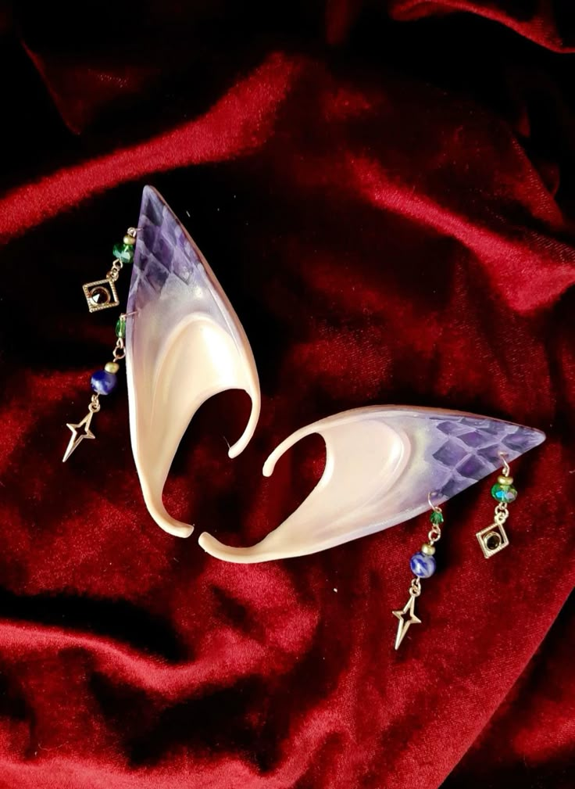

She gave a loud HURUUUU!. A thick, fluffy white tiger like animal with light-gray markings and dark stripes, its pink ears being the highlight came running from the deeper caves to her. She slowly climbed on her. It had very large, medium-length fluffy tail that winded around her body as she let loose her injured hand and caught it with one hand for grip.

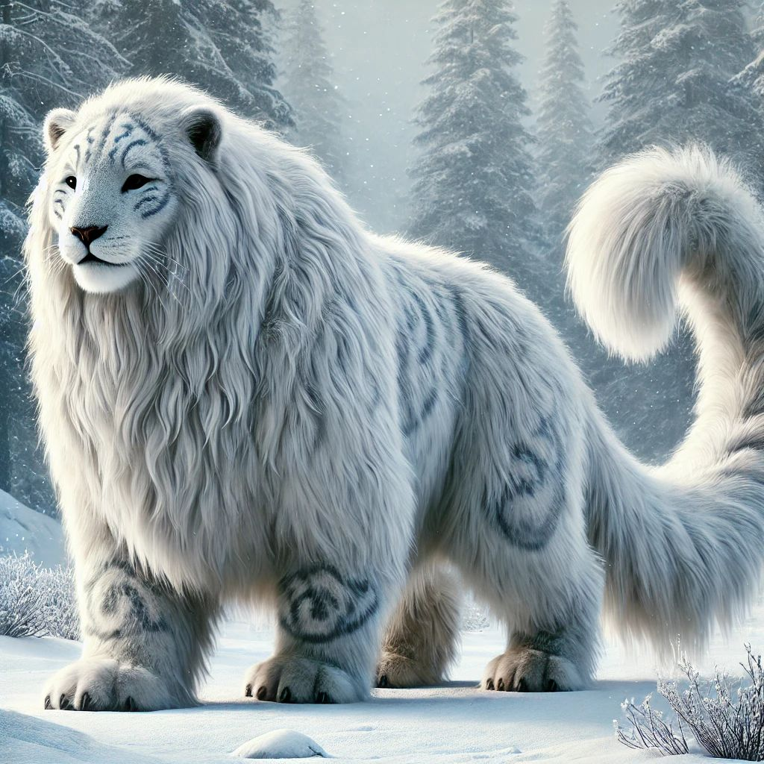

Asmitha: (to the tiger, caring) Polam! Joot!
Ragul silently watched the white tiger gracefully jump and run away.
//EXTERIOR - PLUFFINE FOREST - NEAR SANCTUARY//
The Armored Guy stepped forward, his ice-blue sword gleaming. Without hesitation, he charged straight at her. Dharshna stood frozen, her body trembling as the danger became clear.
Before Dharshna could move, Kanagaraj appeared, blocking the sword with his forearm. The blade penetrated through his armor and damaged it, but he didn’t flinch. Gritting his teeth, he pushed hard the Armored Guy back, forcing him to retreat a few steps.
Dharshna: (scared) Aiyo Kanagaraj!
“Naan paathukuren!!” Kanagaraj shouted, his voice firm but protective.
The Armored Guy steadied himself, his movements calm and focused. Dharshna’s breath caught as he lunged again, his blade aiming straight for her neck.
She froze, her mind blank with panic. But Kanagaraj was faster. He stepped in, catching the blade with both his hands just inches from her face. With a burst of strength, he pushed hard the attacker back, but the Armored Guy spun midair, landing smoothly before charging again.
Dharshna couldn’t move, her body trembling as fear gripped her. “Yen yennala nagara mudila?” she thought, panic rushing through her chest.
The blade came slashing down again, but Kanagaraj crouched just in time.
Kanagaraj: (to the Armored guy, chill) Yennoda mobile ah damage panni oru use-um illa!
Ignoring his words, the Armored guy’s sword whooshed through empty air. Wasting no time, Kanagaraj delivered a sharp kick to the Armored Guy’s leg. The attacker staggered but stayed steady, his cold eyes locked on Dharshna.
“Namma idha pesi-” Kanagaraj shouted, frustration breaking through his voice.
Before Kanagaraj could finish, The Armored Guy swung his sword again, forcing Kanagaraj to roll out of the way. The blade slammed into the ground, leaving a shallow cut in the snow.
Kanagaraj’s breathing grew heavier but he was worryless.
Kanagaraj (to the Armored guy, laughing): Yenna vida speed Kami dhan neenga
The Armored Guy moved again, his blade striking with deadly accuracy. Kanagaraj easily dodged it, but the attacker followed up with a hard blow to his shoulder. His armor cracked and was about to fell off. But Kanagaraj didn’t feel any pain. He was calm as ever.
“Kanagaraj!” Dharshna screamed, her voice cracking.
He glanced at her, smiling. “Onnu illa! Bayapadadheenga!”
He slammed his palm into the earth as he said “Ippo yennoda power ah paarunga”, as he crouched and charged the snow beneath him with both his hands.
The ground shook as electric infused explosions burst all around the armored guy, the air rippling with heat. The shock was intense, exploding with a strange red hue. But then, he stepped out of the smoke, untouched. He was completely fine, not a single mark on him.
Kanagaraj: (thinking, calm) Yen vela seiya maatingudhu?
The Armored Guy charged through the snow and swung his sword with precision, his blade slicing across Kanagaraj’s side completely breaking his armor, but his gloves still intact. He staggered back, barely staying on his feet.
Kanagaraj (muttering, calm): Mobile pochu!!
Dharshna screamed, fear streaking her face. “Kanagaraj!”
Dharshna (to herself): Na yedachum pannanum. Ipdiye naan ninnutu irundha, avan Kanagaraj-ah konnuduvan.
The Armored Guy moved slowly, his sword raised high, ready to strike Kanagaraj’s neck. He was gasping for air.
“Indha power munnadi use pannapo, neraya perukku danger aayirukku. Kanagaraj-kum ippo apdi aachuna, na enna panna?” Dharshna’s mind raced, torn by doubt and fear.
She glanced at her trembling palms, uncertainty filling her. “Ennaala mudiyuma?”
Suddenly, the locket around her neck slipped free, landing in her hand. She stared at it, and determination sparked within her.
Looking at Kanagaraj’s calmness, her hesitation vanished. She tied the locket firm in her wrist. Flames ignited in her palms, burning brighter as her fear turned into resolve.
“Avan kitta irundhu dhooram po!” Dharshna yelled, her voice trembling but strong. The locket tied to her neck reflected the yellow flames in her hands. She thrust her hands forward, sending a wave of fire at the Armored Guy.
Flames surged towards him, with a quick pace. For a moment, Dharshna thought she had him. But the armored man’s sword began to glow, frost spreading across its blade. With one swing, he cut through the fire, turning it into steam.
Dharshna froze, her confidence shaken. “Illa… idhu pathadhu,” she whispered, fear creeping in.
She tried again, sending another wave of flames but much wider. He swung again, but this time, the armor, at his hand, began to melt. Kanagaraj, watching, was confused. “Avanga power yepdi avan mela work aagudhu?!”
The armored man paused for a moment but then charged at Dharshna, furious.
Quickly, Kanagaraj grabbed the man’s leg with both hands, holding him back. Unable to attack with his sword, the armored man kicked Kanagaraj in the face. But he gave no reaction, as it didn’t do any damage except pushing his head back.
“Dharshna, ippo!” he shouted, his voice delighted.
Dharshna shot flames again, but suddenly, the armored man sank into the ground and merged with the shadows below and disappeared.
His shadow stretched across the ground like water. His shadow was much darker than the rest of the shadows Kanagaraj’s eyes widened in alarm. “Dharshna, anga nikkadhinga!” he said with an energetic voice.
But before Dharshna could move, the man reappeared in front of her. He struck her down with one powerful blow. She tried to dodge, taking the hit to her side, and collapsed, crying out in pain.
Tears filled her eyes, blurring her vision. The pain in her side was unbearable, and she couldn’t stop herself from crying out. “Ahhhh!!”, she screamed. Suddenly her back flamed up. The Armored Guy moved a few steps back noticing the fire. She didn’t feel the heat, only the pain from the slash.
She tried to get up, but the pain was too strong. Her body shook, but she noticed the flame and quickly rolled in the snow as the flames were put off but she was struggling to breathe through the sharp ache.
“Sorgathula kooda nimmadhiya iruka mudiyadha?” she cried.
Every breath felt like it was tearing her apart. Her back along with the cut area was dusted with snow due to the roll.
“Illa.. illa.. Na yendhirikanum. Illana avan yenna konnuduvan” she thought, but the tears kept coming, no matter how hard she wiped them away. The Armored guy came closer again since the fire from her had been put off and was ready to deal the final blow.
At that moment, Kanagaraj stared at her cry. His wide smile faded, replaced by an expression of intense, piercing curiosity. A memory surfaced.
[ The pink-flowered girl and Kanagaraj were sitting in an ice cavern surrounded with stagnant water bodies. There was a campfire in front of them, burning bright.
The pink-flowered girl stared at her own hands, which are trembling.
Kanagaraj: Asmitha, unga kai… yen ipdi nadungudhu? Neenga sonningale… kuluru. Adhu-naalaya?
Asmitha: Idhu kuluru naala illa, indha amaidhi naala. Idhu romba sathama iruku.
Kanagaraj: (confused) Amaidhi yepdi sathama iruka mudi– (interrupting)
Asmitha (she gives a short humourless laugh more like a sob): Yen-na, na irundha yedathula, anga…. Yeppomey oru paatu odikitu irukum. Andha paatu dhan na yeppo yenna pannanum-nu sollanum. Oru perfect-aana paatu… na yeppo yendhirikanum, kulikanum, saapdanum, sirikanum… yellathaiyum adhan solluchu. Nee anga yosikkavey theva illa. Andha paata mattum… keta podhum. Adhu soldrapadi senja podhum. Adhu apdiye megathula colour adicha oru alagana jail.
Kanagaraj: Aprom yen anga irundhu vandheenga? Paatu keka yevlo nalla irukum theriyuma? Inga Shreesha nu oruthi irupa blue rose la, ava super-ah– (interrupting)
Asmitha: Aana na keta paatu apdi illa.
She quickly realized that she interrupted him
Asmitha: (calmly) Na ipdi-dhaan. Innoruthavinga solli mudikaraku munnadiye pesa aaramichuduvan. Apdiye yenaku palagiruchu. Adha kandukaadha. (smiling) Na keta paatu, adhu oru… oru… (her hands shaking hard) kirukkan-oda paatu. Andha kirukkan oda instruments dhaan nanga. Noothu kanakkana instruments… andha paatu-ku thala mandai aatitu, vesham potutu, sirichitu irukanga. Na yepdio andha paata niruthitan. Aana innum neraya per anga, yen-nu theriyama adha ketutu irukanga. Yepdiyavadhu avangalaiyum veliya kondu-varanum. (determined, clenching her fists) Andha paata niruthanum.
Asmitha looks down at her bruised arm wounded from the top of the elbow to the broken fingernails covered protectively with Pluffine cloth. She traces it slowly with her thumb.
Asmitha: (voice hardening, her eyes reflecting the campfire) Enkitta irundha puthagamum adhey madhiri dhaan, Kanagaraj. Idhu kaila irundha, ulagathula nadakkura yella unmaiyum, yella aabathum, yella probabilities-um moolaikku direct-ah varudhu. Aana... yellamey therinjikitta… nammalala onnum maathamudiyadhunu theriyavarum… adhu yedho oru jail ulla irukura madhiri iruku!
Kanagaraj tilts his head, listening intently as the fire crackles.
Asmitha: (looking up at him, fiercely) Indha ulagam yedho race mathiri arivu use panni nammala yellaraiyum oda vekkudhu. Aana, uyira kaapathika namma unarchi yellam yeduthutua… namma indha ulagatha jeika poradhilla. Indha ulagandha nammala jeikum. Andha Book ah na tholachadhula konjam kooda varutham illa yenaku.
Kanagaraj’s expression shifts to a bright-eyed excitement, understanding her defiance.
Kanagaraj: (confused, smiling widely) Romba bore aana game polyaye… Neenga sonna game yennaku pudikala. Qwehehehe! Adhey madhiri ungalukku indha 'perfect song' pudikala!
Suddenly she felt a jolt of pain in her left arm which was covered protectively with pluffine cloth.
Asmitha: Andha paatuku munnadi… na kadasiya keta satham… avalodadhu. Yen friend yenakaaga andha vandila yerunadhu. Avala-la dhan… (tears rolled down her eyes) Avala-la dhaan… yenakoru pudhu vaazhka kedachudu. Aana ippo yenaku nyabagam irukuradhu yellam indha paatu mattum dhan.
Kanagaraj slowly listened to what she said. He saw her face as he had never seen something like that before as Asmitha continued to insert dry sticks in the bonfire. Her face reflected in the stagnant water nearby along with the burning flames.
Kanagaraj: Unga kannula irundhu yepdi thanni varudhu… Idhu yedhuku use– (interrupting)
Asmitha: Use..ah apdi lam yedhuvum illa. Yenna solla… namma feelings yellam neraya sendhuruchuna, namma odambu-naala neraya yethuka mudiyadhu. Odanjirum. Adhaanala dhan adhu veliya ipdi kanneer-ah kondu vandhurum. Andha maari irukavangaluku yaarachu kooda irukanum. Avungaluku yaravadhu udhavanum. Illana ulla neraya sendhu sendhu odanju poiruvanga.
Kanagaraj: Ungaluku appo neraya feelings–
Asmitha: Aama. Yepdi yellam naanum yen friend-um jolly ah velandom nu nenachadhu naala vandha feelings, Yedhukuney theriyama andha paata ketutu iruka avangala nenachu paridhavapattu feelings, thirumba andha paata na ketruvangara bayathula feelings… idhellam ulla mix aagi apdiye kannula veliya varudhu. Aana… idhudhaan, na innum naana irukan-u solludhu. Anju varsham kalichu ippo dhan yenaku modhal dhadava kanneerey varudhu. Indha kanneer dhaan (she stands up determined) yenaku kedacha freedom ku proof.
]
Kanagaraj: (to himself, putting pieces together) Modhalla andha red colour liquid varudhu. Adhuku aprom andha oru maadhiri satham… aprom kannula irundhu thanni. Asmitha-vum ipdi dhan pannanga. Yellam orey madhiri nadakudhu. Idhuku yenna artham? Idhu yenna indha game-la pudhusa?
His expression shifted from profound confusion to a sudden, bright-eyed excitement. This was a new, unpredictable phase of the game! “Dharshna!” Kanagaraj screamed, his voice filled with a manic energy.
Kanagaraj didn't panic. He quickly raised his left hand, tapping a rhythmic sequence against his dull grey index fingernail. Two quick taps, a pause, and one final tap.
Instantly, the grey tint vanished from his nail, returning to a normal color as a bright, holographic ellipse of white light materialized in the air. From the light, a pair of heavy, reinforced combat gloves dropped directly into his waiting hands. Dharshna watched in stunned awe as he equipped them in a fraction of a second.
Using all his strength, Kanagaraj jumped onto the armored man, locking his arms around his neck and his legs around his waist. Red shocks burst on his armor as he thrusted his palm on the armor, light reflecting from his armor around the area they stand. Kanagaraj grinned “Ippo unnala maraya mudiyadhu dhaana? Yennoda power work aagala-na yenna?! Yennoda kai-ye podhum!” he shouted.
Dharshna stood frozen, unsure what to do. “Yennala aim panna mudiyala… rendu perum pakkathulaye irukanga,” she said, trembling.
Kanagaraj looked at her and shouted, “Ponga! Dharshna, Odunga! Avan ungala dhan thorathuran. Game-ah mudiya vidadheenga!”
Tears filled her eyes as she hesitated. “Unna vittutu… yepdi?!”
“PONGA!” Kanagaraj roared, laughing with exhilaration as he struggled to hold the armored man in place.
Dharshna stumbled to her feet, her sobs echoing as she ran with her arm holding her wound. She disappeared into the distance, her cries fading into the forest.
As she left from their view, she finally saw the Armored Guy breaking free of Kanagaraj’s hold and raising his large blade preparing to slash him with ground.
Dharshna turned her head and ran, her side hurting with every step. She pressed her arm against the wound, but blood kept dripping.
Dharshna: (struggling to breathe): Yaaradhu irukingala… Somebody… help.
Her legs gave out, and she fell to her knees. Her footsteps stained with blood were visible in the snow and went a long way. Now, she couldn’t move. She tried to lift her head, but her body refused. Then, through the haze, she saw them. It was four legs.
She blinked, trying to focus.
When she looked up, she saw Dhanasree sitting on the deer, the edge of the cloth tied in her forehead waved due to the wind.
Tears filled her eyes, and a small smile appeared on her face. “Dhanasree…” she whispered in hope.
Dhanasree stretched out her hand to Dharshna. Dharshna grabbed it weakly, squirming in pain, and climbed onto the deer behind her. The deer took off, sprinting through the dense forest, its hooves thudding softly against the earth.
Dhanasree glanced back, her heart sinking as she noticed the Armored Guy blending into the shadows, his ice blade clear even in the growing darkness. He was fast and relentless.
Dhanasree: (firmly) Dharshna, gettiya pudichiko! (gripping the antlers) Avan namma pinnadi dhaan vandhutu irukan!
Dharshna leaned against her, her breathing slow. Blood stained her side, her face pale. “Yennala… yennala mudila… Dhanasree" she murmured, her voice weak.
Dhanasree: (glancing back at her with concern) Dharshna onnum illa, chinna kayam dhan. Just stay awake. (glancing over her shoulder to check for the armored guy) Stay with me, Dharshna!
The trees grew thicker, and shadows stretched longer as the dark clouds surrounded the sky. The forest became eerily quiet, the only sounds coming from the deer’s hooves and Dharshna’s heavy breathing.
Dhanasree: (muttering) Romba iruitikitey iruku. It’s really bad for us. (frustrated, to Dharshna) Namma ippo sunlight, illana, bright aana place-ah kandu-pudikanum. Illana avan nammala easy-ah pudichiduvan.
Dharshna let out a weak laugh,
Dharshna: (muttering) Motha kaadum… yennala… pathikitu yeriyudhu. Anga po…
Dhanasree gave a displeased look but didn’t respond immediately. Her mind was racing with a hundred thoughts at once.
Dhanasree: Udaney namma ippo Rahul-ah kandu pudikanum.
Dharshna blinked, confused. "Rahul-ah? Yen?"
Dhanasree: (blunt, her voice cold) Avanala mattum dhaan andha armor kaaran-ah kolla mudiyum.
Dharshna: (tensed, her pain momentarily forgotten) Kolai-ah? Nee serious-ah dhaan pesitu irukiya? Andha armored person yevlo strong-nu theriyuma?!
Dhanasree pulled the deer to a sudden stop, turning to glare at Dharshna.
Dhanasree: (firm) Aama. kola-dhaan. Neenga rendu perum sendhu dhaan panna poringa.
Dharshna: (confused) Illa, I don’t understand. Naan yen avana kola pannanum?
Dhanasree: Appo dhaan namma uyiroda inga irundhu poga mudiyum. Rahul yenga irukan-nu yenaku theriyum. Ivan kitta irundhu thappicha mattum podhum.
Dharshna: (insisting) Aana… Aana Kanagaraj anga irukan..!
Dhanasree: (tense) Adhu yaru?
Dharshna: (getting down the deer, voice soft) Avan dhaan yenna kapathunan. Avan… avan… mattum illana… (sobs) na angaye sethurupan. (firm) Modhala avanuku poi udhavi pannuvom.
Dhanasree: (getting down the deer, clenching her fists) Yenna pesitu iruka nee?! Na inga yellar pathiyum yosichitu irukan… Andha armor kaaran mattum unna konnutaana, yellamey mudinjidum. Kanagaraj-ah vadhu m*iravadhu.
Dharshna: (shouting) Kanagaraj pathi apdi pesadha! (tears welling in her eyes) Avan dhaan yenna kaapathunan! Avan anga-dhaan irukan. (pointing the forest) Avana apdiye vittutu poga soldriya?!
The deer was moving around, sensing the tension in their voices.
Dhanasree’s voice softened slightly, but her words were still sharp.
Dhanasree: Avana apdiye vida sollala. Nammaloda best choice yennavo, adha dhaan pannalanu sonnan. Andha armor-kaaran vandhutu irukan. Unnoda Kanagaraj anga uyiroda irukana, illa sethutaana-nu kooda namaku theriyadhu. Inga irundhu thappichu Rahul-ah kandupudikaradhu dhaan best choice.
Dharshna stared at her, breathing heavily. She looked torn, her emotions pulling her in every direction.
Dharshna: (quietly, voice breaking) Naan thappikanum-nu dhan avan sanda potan. Avana yepdi naan apdiye vittutu poga mudiyum?!
Before Dhanasree could respond, a chilling sound echoed through the trees—the sharp, metallic scrape of a blade against bark.
The Armored Guy was close.
The sound of metal scraping against wood got closer. Dharshna froze. Dhanasree quickly climbed onto the deer.
Dhanasree: (pulling Dharshna’s arm): Vandhu yeru!
Dharshna shook her head, eyes full of tears.
Dhanasree: (sharply) Ippo polana avan nammala konnuduvan! Seekram!!
Unwillingly, Dharshna hoped on the deer.

